Jon Green

Module 5.2 Value Stream

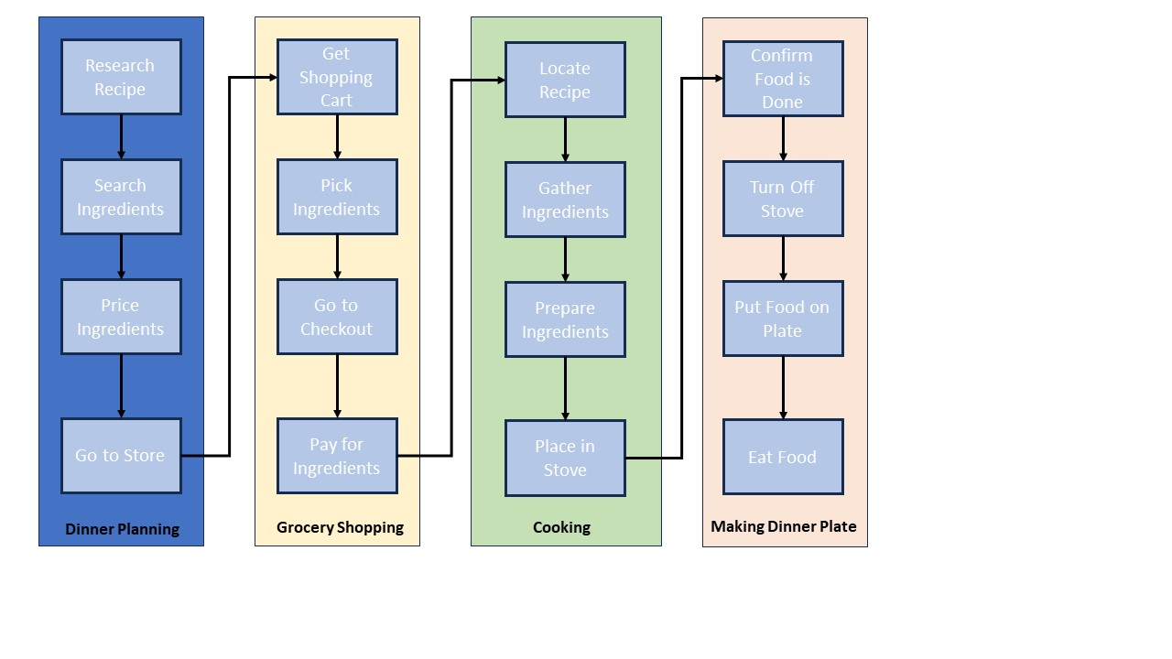

Analyzing Lean Metrics

Estimated Average Time Flow

|  |  |
| --- | --- |
| Dinner Planning | 1 hour |
| Grocery Shopping | 30 mins. |
| Cooking | 1 hour |
| Making Dinner Plate | 15 mins. |

|  |
| --- |
| Estimated Cycle Time: 2.75 hours |
| **Optimizing Food Meal Preparation:**  **Eliminating Waste:** I can eliminate 1 hour during dinner planning by ordering the ingredients online and having them delivered to my home. An additional 15 mins can be saved during shopping by ensuring that the required ingredients are not already in my pantry.    **Workflow Orchestration:** I can move the option to pay for ingredients from the grocery shopping section to the dinner planning section if I plan to shop online. Locating recipe can also be moved to the grocery shopping section. This will ensure that all ingredients are accounted for before cooking.  **Governance Models:** The food cooking section does not indicate an option to check for proper food cooking temperatures. This may pose a potential food safety issue if the correct temperature is not utilized. | |